成绩：

实 验 报 告

课程名称： | 虚拟现实建模技术
实验项目： | Mesh编程构建分形平面几何模型
姓 名：
专 业： | 计算机科学与技术
班 级：
学 号：

计算机科学与技术学院

2021年 4 月 8 日
实验项目名称：Mesh编程构建分形几何模型
一、实验目的
通过MESH编程绘制分形平面几何模型
二、实验内容
1、简述本实验所用到的Unity组件
2、设计通过Mesh编程实现分形平面几何模型的方法（算法）
3、通过Mesh编程绘制分形平面几何模型（带注释的程序）
三、实验原理
1.KOCH曲线
使用Linerender组件，通过给定线段顶点的个数和坐标，存入list中，就能画线。由于是等边三角形，在递归过程中创造的新点坐标可以通过两个端点计算出。不断在每一条边进行递归，得到每个顶点的坐标，中间新创造的点由以下数学关系可得：
p[1].x = p[0][0] + dis * Mathf.Cos((theta - 60.0f) * pi / 180);
p[1].y = p[0][1] + dis * Mathf.Sin((theta - 60.0f) * pi / 180);
2. 谢尔宾斯基三角形
首先先创建一个大三角形，以下不断根据每边中点获取新点的坐标，用三个新点继续画三角形，直至递归结束。
四、实验结果及源代码
1. 谢尔宾斯基三角形
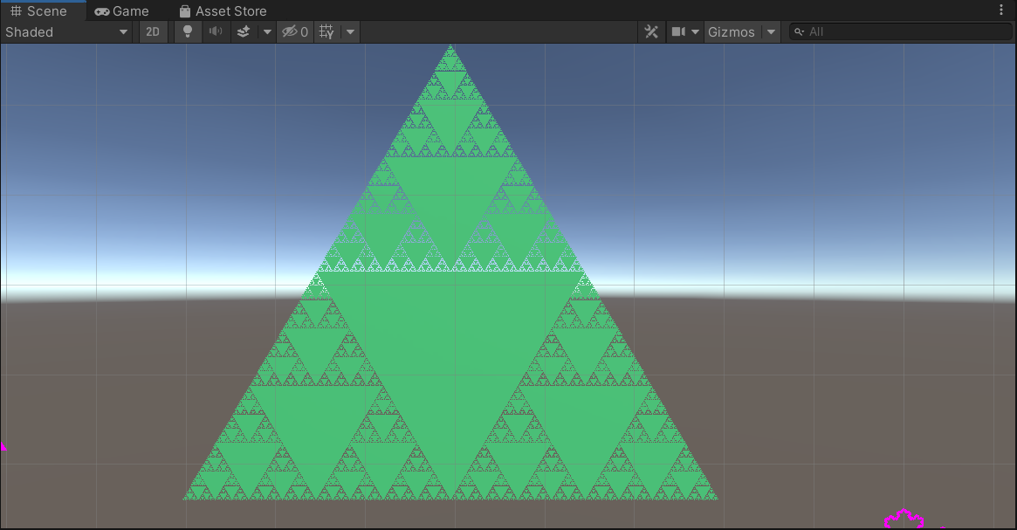
using System.Collections;
using System.Collections.Generic;
using UnityEngine;

public class fenxing : MonoBehaviour
{
public Material mat;
public int n=3; //递归次数
public Vector3 A;
public Vector3 B;
public Vector3 C;
public List<Vector3> vertices = new List<Vector3>();
public List<int> triangles = new List<int>();
public int num = 0; //辅助list添加的计数器
public List<Vector2> UV = new List<Vector2>();
// Start is called before the first frame update
void Start()
{
draw(n);
}

// Update is called once per frame
void Update()
{

}

void draw(int n)
{
gameObject.AddComponent<MeshFilter>();
gameObject.AddComponent<MeshRenderer>();
Mesh mesh = GetComponent<MeshFilter>().mesh;
gameObject.GetComponent<MeshRenderer>().material = mat;

//首先将第一个三角形确定下来，方便后续递归
vertices.Add(A); //获取顶点数组
triangles.Add(num); //按顺序添加三角形
num++;
vertices.Add(B);
triangles.Add(num);
num++;
vertices.Add(C);
triangles.Add(num);
num++;

digui(A, B, C, n);

//将所有顶点送入 mesh.vertices
mesh.vertices = vertices.ToArray();
mesh.triangles = triangles.ToArray();
mesh.uv = UV.ToArray();
mesh.RecalculateNormals();

}

void digui(Vector3 a, Vector3 b, Vector3 c,int n)
{
//if (n <= 0)
// return;

//递归结束时画出当层的3个点组成的三角形
//计算新的3个点的坐标，根据每边中点得出
Vector3 midleft = new Vector3((a.x + c.x) / 2, (a.y + c.y) / 2, 0);
Vector3 middown = new Vector3((b.x + c.x) / 2, (b.y + c.y) / 2, 0);
Vector3 midright = new Vector3((a.x + b.x) / 2, (a.y + b.y) / 2, 0);
vertices.Add(midleft);
UV.Add(midleft);
triangles.Add(num);
num++;

vertices.Add(middown);
UV.Add(middown);
triangles.Add(num);
num++;

vertices.Add(midright);
UV.Add(midright);
triangles.Add(num);
num++;
if (n > 0)
{
digui(a, midright,midleft,n - 1);
digui(midleft, middown, c, n - 1);
digui(midright,b,middown,n-1);
}
}
}

2. 谢尔宾斯基三角形。经与同学比对后，画出一个空心的图形。
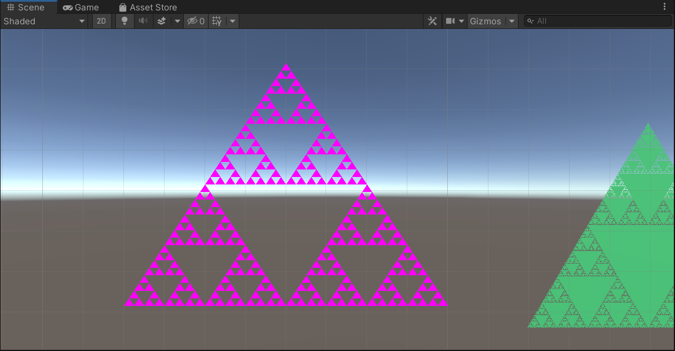
using System.Collections;
using System.Collections.Generic;
using UnityEngine;

public class test1 : MonoBehaviour
{
public Material mat;
public int num; //递归次数
public List<Vector3> ver = new List<Vector3>();
public List<Vector2> UV = new List<Vector2>();
public List<int> tri = new List<int>();
int count = 0;
bool Flag = true;
// Start is called before the first frame update
void Start()
{
draw();
}

void draw()
{
gameObject.AddComponent<MeshFilter>();
Mesh mesh = GetComponent<MeshFilter>().mesh;

gameObject.AddComponent<MeshRenderer>();
gameObject.GetComponent<MeshRenderer>().material = mat;

//Vector3 loc = gameObject.transform.position;

Vector3 left = new Vector3(-40, -30, 0);
Vector3 right = new Vector3(+40, -30, 0);
Vector3 up = new Vector3(0, +30, 0);

Digui(0, up, right, left);

mesh.vertices = ver.ToArray();
mesh.triangles = tri.ToArray();
mesh.uv = UV.ToArray();
mesh.RecalculateNormals();

}

// Update is called once per frame
void Update()
{

}

void Digui(int layer, Vector3 up, Vector3 right, Vector3 left)
{
if (layer == num)
{
ver.Add(up);
UV.Add(up);
tri.Add(count);
count++;
ver.Add(right);
UV.Add(right);
tri.Add(count);
count++;
ver.Add(left);
UV.Add(left);
tri.Add(count);
count++;
return;
}
else
{
Vector3 midright = new Vector3((up.x + right.x) / 2, (up.y + right.y) / 2, 0);
Vector3 middown = new Vector3((left.x + right.x) / 2, (left.y + right.y) / 2, 0);
Vector3 midleft = new Vector3((up.x + left.x) / 2, (up.y + left.y) / 2, 0);

Digui(layer + 1, up, midright, midleft); //上三角
Digui(layer + 1, midright, right, middown); //右三角
Digui(layer + 1, midleft, middown, left); //左三角

}
}

}

3.koch曲线
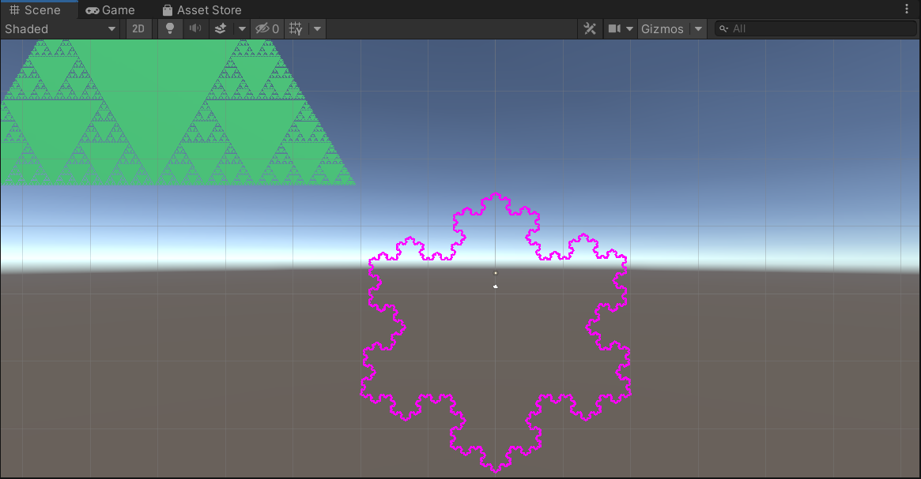
using System.Collections;
using System.Collections.Generic;
using UnityEngine;

public class test : MonoBehaviour
{
public LineRenderer line, line1, line2;
public int size;
public List<Vector3> list = new List<Vector3>();
public List<Vector3> list1 = new List<Vector3>();
public List<Vector3> list2 = new List<Vector3>();
private float theta = 0;
float pi = Mathf.Acos(-1);
private bool IsAdd;

private void Start()
{

}

private void Update()
{
if (!IsAdd)
{
IsAdd = true;
//顶点个数
line.positionCount = (int)Mathf.Pow(4, size) * 2;
line1.positionCount = (int)Mathf.Pow(4, size) * 2;
line2.positionCount = (int)Mathf.Pow(4, size) * 2;
//初始位置的3段线
divide_line(new Vector2(-20, -15), new Vector2(20, -15), size, 0);
divide_line1(new Vector2(0, 15), new Vector2(-20, -15), size, -120);
divide_line2(new Vector2(20, -15), new Vector2(0, 15), size, 120);

//设置线上的所有顶点
for (int i = 0; i < list.Count; i++)
{
line.SetPosition(i, list[i]);
}
for (int i = 0; i < list1.Count; i++)
{
line1.SetPosition(i, list1[i]);
}
for (int i = 0; i < list2.Count; i++)
{
line2.SetPosition(i, list2[i]);
}
}
}
void divide_line(Vector2 p1, Vector2 p2, int n, float theta)
{
if (n > 0)
{
Vector2[] p = new Vector2[3];
//根据两个端点计算出新创建的第三个点
float dis_x, dis_y, dis;
dis_x = p2.x - p1.x;
dis_y = p2.y - p1.y;
dis = Mathf.Sqrt(dis_x * dis_x + dis_y * dis_y) / 3;
//将线段3等分,通过偏移的形式求出对应坐标
p[0].x = p1[0] + dis_x / 3;
p[0].y = p1[1] + dis_y / 3;
p[2].x = p2[0] - dis_x / 3;
p[2].y = p2[1] - dis_y / 3;
//新点坐标
p[1].x = p[0][0] + dis * Mathf.Cos((theta - 60.0f) * pi / 180);
p[1].y = p[0][1] + dis * Mathf.Sin((theta - 60.0f) * pi / 180);
//经分段后有4条线段，依次画出
divide_line(p1, p[0], n - 1, theta);
divide_line(p[0], p[1], n - 1, theta - 60);
divide_line(p[1], p[2], n - 1, theta + 60);
divide_line(p[2], p2, n - 1, theta);
}
else
{
//递归结束 将当前剩余两个端点加入list
list.Add(p1);
list.Add(p2);
}
}
void divide_line1(Vector2 p1, Vector2 p2, int n, float theta)
{
if (n > 0)
{
Vector2[] p = new Vector2[3];
float dis_x, dis_y, dis;
dis_x = p2.x - p1.x;
dis_y = p2.y - p1.y;
dis = Mathf.Sqrt(dis_x * dis_x + dis_y * dis_y) / 3;
p[0].x = p1[0] + dis_x / 3;
p[0].y = p1[1] + dis_y / 3;
p[2].x = p2[0] - dis_x / 3;
p[2].y = p2[1] - dis_y / 3;
p[1].x = p[0][0] + dis * Mathf.Cos((theta - 60.0f) * pi / 180);
p[1].y = p[0][1] + dis * Mathf.Sin((theta - 60.0f) * pi / 180);
divide_line1(p1, p[0], n - 1, theta);
divide_line1(p[0], p[1], n - 1, theta - 60);
divide_line1(p[1], p[2], n - 1, theta + 60);
divide_line1(p[2], p2, n - 1, theta);
}
else
{
list1.Add(p1);
list1.Add(p2);

}
}
void divide_line2(Vector2 p1, Vector2 p2, int n, float theta)
{
if (n > 0)
{
Vector2[] p = new Vector2[3];
float dis_x, dis_y, dis;
dis_x = p2.x - p1.x;
dis_y = p2.y - p1.y;
dis = Mathf.Sqrt(dis_x * dis_x + dis_y * dis_y) / 3;
p[0].x = p1[0] + dis_x / 3;
p[0].y = p1[1] + dis_y / 3;
p[2].x = p2[0] - dis_x / 3;
p[2].y = p2[1] - dis_y / 3;
p[1].x = p[0][0] + dis * Mathf.Cos((theta - 60.0f) * pi / 180);
p[1].y = p[0][1] + dis * Mathf.Sin((theta - 60.0f) * pi / 180);
divide_line2(p1, p[0], n - 1, theta);
divide_line2(p[0], p[1], n - 1, theta - 60);
divide_line2(p[1], p[2], n - 1, theta + 60);
divide_line2(p[2], p2, n - 1, theta);
}
else
{
list2.Add(p1);
list2.Add(p2);
}
}
}

